CAREER EPISODE 3: As a Facilities Engineer at Hitachi Global Storage Technologies (HGST)
INTRODUCTION
CE 3.1 This career episode transpired when I was transferred to Facilities Department as Facilities Machinery Section Engineer in charge handling mechanical operation and maintenance from December 2004 up to September 2007 with 4 direct facilities technicians and 6 contract based facilities outsource personnel. Hitachi GST is located in Biňan, Laguna inside the premises of Special Export Processing Zone, Laguna Technopark engaged in the manufacturing of hard disk drives. Facilities department is supporting the plant’s critical utilities such as power, water, air-conditioning, compressed air and relevant heating, ventilation and air-conditioning equipment 24 hours a day.
Figure 3.1: HGST Facilities Central Plant Area at LTI, Biňan, Laguna

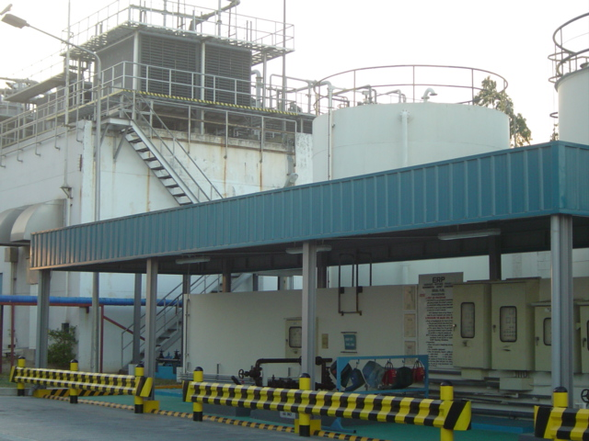
BACKGROUND
CE 3.2 The plant operates 24 hours a day and all utilities should remain uninterrupted. There were only 2 scheduled plant shutdowns in a year to give way for equipment maintenance. Critical equipment involving Air Handling Units (AHU’s) which serves the production load plant-wide. Also compressed dry air system comprising of air compressors and air dryers and its auxiliaries such as pressure air receiver tanks as well as vacuum pumps were maintained operational as these caters the production clean room air requirements on production machines.

CE 3.3 Below is a Chart of the Organization at Hitachi GST Facilities Department:
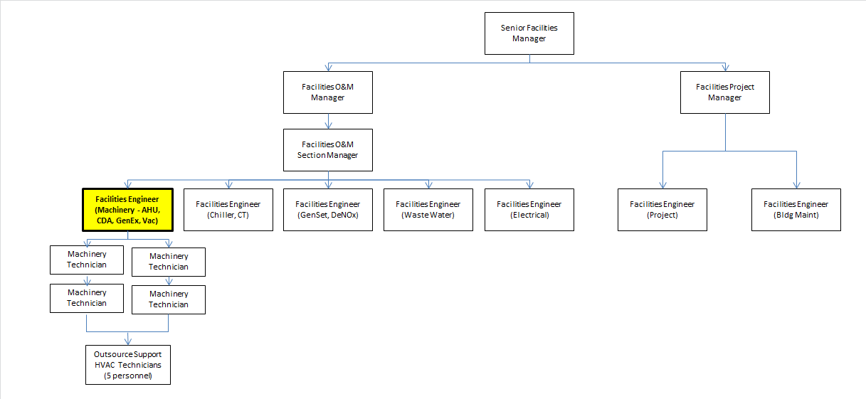

CE 3.4 As the Facilities Machinery Section Engineer, my roles and responsibilities are the following: I was responsible for ensuring continuous supply of utility requirements to production department. I was in-charge for operation and maintenance schedule of Air Handling Units (AHU) and its auxiliaries and kept records of operations & maintenance checklists, equipment’s history and log sheets and ensure that all events are properly monitored within the standard set values. I was also coordinating with production engineers any related work or changes that may affect operation and cause delay in production.

PERSONAL ENGINEERING ACTIVITY
CE 3.5 Upon joining the facilities department, I had been instrumental in the system equipment hardening programs. I had been very active in resolving key customer issues and concerns on office air-conditioning temperature balance, compliance to pressure relief vessel annual inspection, testing and sustaining programs on air receiving tanks, improved spares management by fast-paced purchase requisitions established thru identifying key vendors for common spare parts etc.
CE 3.6 I contributed the following challenges/opportunities that need to be addressed. First, an observationhas been raised when I found out that there had been no awareness on the local code requirement to annually inspect the air receiver tanks and that it should be issued with BLS certificates accordingly. The provisions of this DOLE-BWC requirements was new for Hitachi GST. All air receiver tanks considering 24 hours operation activitiesmust have an imperative local safety compliance to ensure that we are following within the regulation by Philippine Mechanical Engineering Code.
CE 3.7 To address the issues, I demonstrated the following action plans and implemented them accordingly:
For the operation & maintenance check sheet gap, I’ve prepared an Excel sheet that shows the individual operational data limit for critical machinery equipment such as Air Handling Units, Air Compressors, Vacuum Pump, Exhaust Fans and ACU’s of the Power Plant necessary. I developed an innovation called“Year Round Maintenance Plan” to also cover all the scheduled maintenance beside the existing job orders prepared by my senior mechanical technician.
In addition to the ISO 18001 certification process, I was also tasked to lead one major project encountered at one test production floor which involved HDD Test Area issue on high temperature encountered by their oven high discharge. The aim was to reduce the temperature from 35°C down to at least 26°C. There is no exhaust fan and exhaust ducting system installed in that area. The hot air coming from the Test area is only being brought back to the AHU’s for cooling when it should be thrown out of the area and replaced with new fresh air outside. I worked out the solution for our department by designing 1 unit of exhaust fan incorporated with 1 big capacity AHU coupled with 1 small capacity AHU respectively. In collaboration with HDD Test engineers, we had formulated a solution from November 2004 gradually up to early February 2005 period. One significant milestone met from this project was it also served to increase the cooling capacity of AHU without revising existing air duct system within HDD Test Area.The said project initiative had won company wide as President’s awardee for Technological Excellence. The project had been cited having realized a net cost savings at $15k per year equivalent to 180 tons of refrigeration energy conservation by hot air removal and capital cost reduction at $110k. Project had benefited HDD Test area temperature reduction at 8-10°C temperature difference improvement for both the product test environment as well as comfort cooling to female operator production occupants.
CE 3.8 The Year-Round Maintenance Plan Procedures and DOLE-BWC compliance for unfired pressure vessels have been very significant help in the contribution for the successful ISO 18001 plant certification. The machinery section reception of facilities technician’s observation of executedprocedures went well too.No major challenges identified and the revised procedure I made was officially been recognized as a department standard officially. Thus, the entire tracking and documentation I have developed was authorized and was used.
CE 3.9 With the added support of my reinforced revisions on operation and maintenance limit check sheets, everyone have executed within the compliance of Hitachi GST and our Power Plant in particular was able to avoid any penalties upon compliance beyond being cited ISO 18001 plant certified.
CE 3.10 To record, the activity was a success and there were no accidents, nor casualties. We delivered the requirements for plant safety certification on time. The positive impact for me was to gain a new learning process, prove my integrity and the procedures I developed was kept in our Operations & Maintenance section as references to future Hitachi GST peers. Moreover, the legacy of instilling a “safety mindset culture” had been evidenced by performing early morning safety meetings before start of work.

C.) SUMMARY
CE 3.11 Being familiar with the Power Plant configuration and having had a good background in handling large fleet of contractors for my former Power Plant experience served as an advantage. It is a good mastery of technical and management experience, having been leading and spearheading the planning, preparation, working and monitoring of the machinery section I handled. My firm grasp on Power Plant Operations has been developed.Being keen to details and firm on decision making on Safetyand local compliance are the major best practices during my tenure as being the former Safety Engineer for Facilities. We completed the Hitachi GST’s first time ISO 18001 plant certificationand re-intensify the Power Plant without any major accident and without any casualties thru different technical innovation means possible and cost avoidance initiatives.

