CAREER EPISODE 1:

As a Facilities Project & Mechanical Plant Operation & Maintenance Engineer for Maxim IntegratedSemi-Conductor Plant – Gateway Industrial Park, General Trias, Cavite, Philippines

INTRODUCTION

CE 1.1 From August2014 up to present, I worked as a Facilities Project Site Engineer for Maxim Integrated Cavite Plant – Philippines site. Since the company is in the process of plant expansion, the lateral transfer from facilities operation to site project engineer positionwas approved by San Jose, Headquarters, California USA to meet the demands of capable engineers to handle future engineering expansion needs as a requirement.

CE 1.2 Maxim Integrated Plant is one amongst many semi-conductor locators inside Gateway Industrial Park for premises sector. The Plant started its operation in 1996 as Maxim Dallas. Maxim Integrated is the industry leader in the analog/mixed signal semiconductor market.The Facilities Department is one of the pioneer departments handling plant equipment’s operation and maintenance including building as well as handling our outsource support personnel. I was part of the facilities core staff of the Facilities Operation &Maintenance Department specifically for mechanical section at Maxim Integrated Plant site. Having to consolidate all HVAC (Heating, Ventilation and Air Conditioning) Components installed at the two inter-connected production & office buildings and nearby central utility plant.

BACKGROUND

CE 1.3 I was assigned as a Facilities Engineer for HVAC (Heating, Ventilation and Air Conditioning), Compressed Dry Air (CDA) & Vacuum Systems, Chillers, Cooling Towers, Auxiliary chilled/condenser water pumps, Air Handling Units (AHU’s), Fire Protection Pumps and small capacity Domestic Water Systems directly reporting to the Senior Facilities Manager of Maxim Integrated. My main job objective is to supply continuous utilities and monitor all HVAC, CDA & Vacuum requirements both my direct technicians and in-house contractors at Maxim Integrated Plant including the water pump stations nearby, and also to study and propose replacement of old Cooling Tower units and obsolete chilled pumps.

CE 1.4 To address the issue of deteriorated mechanical rotational equipment serving both interconnected building utilities specific for chilled and condenser water pumps of Chillers as well as compressed air water pumps, lacking redundant domestic water pump installation works including obsolete in-line Cooling Towers in current parallel operation, I was assigned to spearhead the project for mechanical works taking care technical matters from project work scope, project bids, budget requisition, execution and project completion as well as hand-over. Being the only mechanical engineer versed in vendor contractor management and experience, I had been chosen to lead the design, coordination and execution of managing such gap.

Figure 1.1: Maxim Integrated, Gateway Industrial Park, Cavite Plant
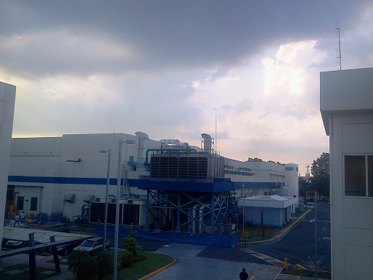

CE 1.5 Below is a chart of Maxim Integrated Facilities department project re-organizational chart showing my links to my superiors and my subordinate:

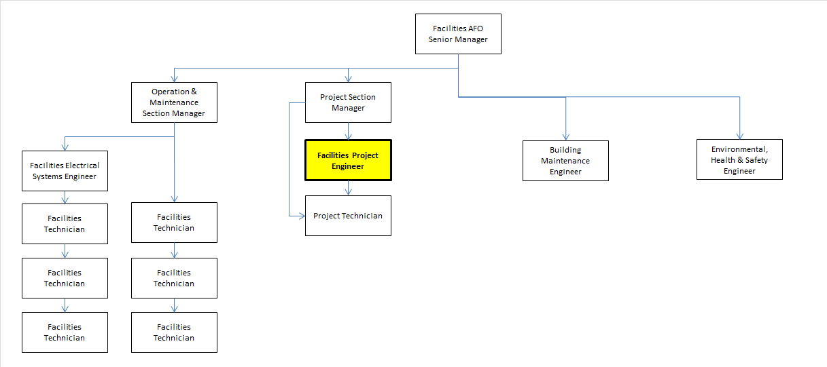

CE 1.6 To carry out the above task, I was responsible to do and perform the following:
I plan and organize a sustainable continuous supply of mechanical utilities for Maxim Cavite site assigned as strategized by top management priorities. I prepare work permits and generate reports concerning involved project contractors or vendors. I established work breakdown structure for a certain project being conceptualized and approved for implementation to be able to meet project deadline as assigned. I managed and monitored performance of handled direct Maxim Cavite technicians on a weekly frequency basis into a written report format. I acted as mechanical lead engineer for critical works involving related plant HVAC works for operation & maintenance execution & vendor contractor in-house. I lead the support in-house vendors and/or contractors in the execution up to completion of a certain periodic schedule of operation and maintenance program. I collaborate with facilities project colleagues in collaboration to complete the project job scope as reflected in the work contract for utilities connection or disconnection, addition or demolition works. I worked with operation & maintenance manager in relation to equipment safety requirements and other documents for compliance before start of in-house or vendor work performance. I created department work instructions as required using company’s document management system or modify an existing one as necessary for the purpose of updating for department’s perusal.
Below is a chart of Maxim Integrated Facilities department’s first operation and maintenance organizational chart showing my links to my superiors and my subordinates:

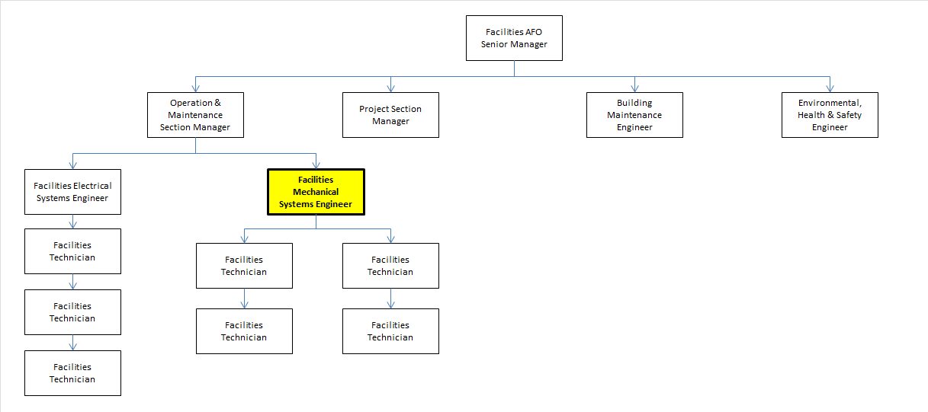

PERSONAL ENGINEERING ACTIVITY

CE 1.7 As a Facilities Engineer, I am directly reporting to our Facilities Section Manager. I coordinated with him and submit my reports regarding any challenges or feedback on our mechanical equipment’s operation & maintenance compliance status. I also provided updates and feedbacks every week about the progress of our meetings and projects to the facilities staff up to our facilities department head.Under my jurisdictionismy four direct hired regular facilities technician employees, the In-House Maintenance Contractors for Cooling Towers and Water Treatment Services and the Project Site Contractors on purchase order basis. I oversee the tasks implemented by our In-House Maintenance and our Project Contractors including performance of my directly handled regular shifting facilities technicians. My main role as a Facilities Engineer is to monitor the In-House Maintenance Contractor and HVAC Contractors overseeing rehabilitation of old HVAC auxiliary pumpslocated in the old building of the Power Plant.I started working on this project by understanding the safety standards mandated by plant safety policies.

CE 1.8 In order to properly facilitate such roles, I have scheduled regular meetings. The main purpose is to seek inputs and generate ideas on how to deal with the objectives of the Company. For the In-House Contractors, I have set a morning meeting to all technicians regularly in the morning for at least one hour, prior checking the equipment. For the Project Contractors, I have set them for a weekly meeting and asked them to submit a progress report. I stressed out the objectives set forth by the Corporate Headquarters, our active roles and functions to meet the standard, and explain the contract and penalties stipulated in the contract clause.

CE 1.9 To improve the Facilities Maintenance Department, I utilized the Cause & Effect Analysis methodologies and was able to evaluate the areas of improvement brought up from the meetings held with stakeholders involved, which are: First, the HVAC equipment are in need of rehabilitation or replacement due to their dilapidated condition. There are also added heat load in the area which the current HVAC units are no longer effective, and the availability of the spare parts are already scarce. Next, the In-House Maintenance and Project Contractors have had several pending work punch list or Job Retentions. This equipment was neither reported nor endorsed and are without any back-ups in case of emergency. No reports were submitted on the condition, nor any updates of all the equipment installed as part of the objective in their maintenance contracts. Then, some of the HVAC units were not replaced by the Project Contractors as they were supposed to be and based on my review of their job accomplishments, some of the HVAC units installed are either refurbished or under capacity and even worst without back-up units. Lastly, most of the In-House Maintenance Contractors are not technically capable of HVAC and are not well versed in the English Language. I have to deal with the language barrier, along with mechanical and procedural issues with these technicians.

CE 1.10 In this situation, I applied the Plan, Do, Check and Act Methodology. As a part of the Planning Phase, I used MS Excel and Power Point presentations as tools in generating new Log Sheets, upload them officially on our DMS (document management system) and simplified data for easy conveyance to my colleagues and superiors. I evaluated the generated ideas from our frequent meetings, the following plan includes:I created a “365 days Preventive Maintenance Schedule” on a weekly, quarterly, semi-annually and annually for all the HVAC equipment installed at Maxim Integrated Plant, including the Fire Protection & Auxiliary Water Pumps under our Area. The responsibility for the maintenance is enlisted to all HVAC Facilities Technicians, In-House Maintenance Personnel, Project Contractors and Facilities Engineer colleagues.I also drafted a Preventive Maintenance checklist of Air-Handling Units and Chiller Units, and then I integrated them with the Original Equipment Manufacturer (OEM) Checklist after conducting series of meeting with their technical staff.I identified old HVAC Equipment and made calculations referring to TRANE handbook. I authored a project proposal with a specified budget for the replacement of all the mechanical pumps specific for observed wearing of mechanical seals and bearings. I carefully reviewed the In-House Facilities Maintenance practice and found out that there is no established program for rotating equipmentspecific for Chiller’s chilled water and condenser pumps. I initiated contacting known industry market third party experts specializing in vibration analysis then eventually hired their services and conduct an objective baseline data for these pumps and justify their corresponding bearing & shaft seal replacements.

CE 1.11 The following scopes of the Implementation Phase are as follows:

The Technician’s safety is always our priority in procedural and technical issues on HVAC. Despite being new to the site, I facilitated some training to all the In-House Maintenance Technicians about Safety Procedures in simple, understandable approach. I also invited OEM vendors for Chillers, Air Compressors and Vacuum Pumps since most of the equipment are formerly been purchased and installed thru them. I discussed with them the importance of having a facilities system ownership whereas having such shall benefit the team’s effective handling of mechanical equipment assignment and religiously apply the working principles of preventive maintenance compliance anchored by Maxim Integrated Plant objective of uninterrupted plant utilities.

I submitted the project proposal for the replacement of HVAC units and components. These items include the following:

- Replacement of old and deterioratedmechanical seals and shaft seal bearings for Chilled Water& Condenser Units which are already phased out in the market due to new models are being developed.
- Repair of Fire Protection System from embedded piping main pressure leak.
- Refurbishment of Cooling Tower’s draft fans.
- Additional installation for redundant domestic water pump unit on standby.

I also made recommendations of re-visiting the heat load on office areaslocated at the old building since there are also added heat load in the area, which the current HVAC units are no longer effective by referring to the ASME psychometric guide book. The re-designing of the AHU’s served air duct branches is also essential since some of the supplied main ducts remained not insulatedand requires replacement into insulated commercial types (Fiber-glass type, etc.).In relation to the performance of the Facilities Technicians, I presented the implementation of facilities system ownership program first to my engineering colleague then toour Managers and have them begin implementing as soon as possible. I regularly review all the critical parameters they observed in the log sheets and consistently report it to our Facilities Section Manager and coordinate all the reports of their performance to our Facilities Senior Manager or face corrective actions to implement a discipline and to change the norms ofour techniciansand improve their work flow incorporated on this program.To ensure monitoring of this implementation, I have developed a list of HVAC Components and Spare Parts installed at Maxim Integrated Plant and to all In-House contractors coveredin our area. The list is to be inputted to the new database assigned to one of our senior technician being developed at Facilities Maintenance section which served as monitoring basis every week by inputting all the HVAC components scheduled for due maintenance and review the list, add or subtract items, depending if it is still operational or if it is a newly installed unit.

CE 1.12 With the new guidelines set to facilities technicians, In-house and Project contractors, as per their contracts, I have successfully set a standard of system of accountability. All previously delayed job orders by the In-house Maintenance contractors are properly met in collaboration with facilities technician system owners in order for them to minimize missed scheduled compliance in performing preventive maintenance, thus avoiding possible machine breakdown likelihood.

CE 1.13 Checking and Monitoring of my project are equally important while the on-going process of Implementation is taking place. Testing and Commissioning is one focal action to every HVAC installed. I made sure that all parameters were met before and after said replacement. A total of six chilled and condenser water pump’s mechanical seals and bearings were replaced, with additional four sets at central utility building plant, about 95% of deteriorated HVAC pump mechanical auxiliaries were replaced. With added correction of the perennial fire protection main piping leak was resolved within a year.

CE 1.14 Initially, the Contractors as well as our very own facilities technician faced some difficulty on the new workflow system I have generated since they act on previous norms in the previous administration of the Facilities Plant. Eventually, they have adapted to the Rules and Regulations and have minimized operation downtime incurred from these former lapses in facilities system hardening and improvement being set forth.
Both the Main USA Headquarters Facilities Head and our Senior Manager are satisfied about the outcome of the improvements made. The operation uptime improved from 40-80% and the results of backlog work orders were diminished to 0%.

CE 1.15 My introduction of developing vibration analysis seen thru justification outcome of replacing old HVAC auxiliary units takes time and budget constraint, what I have prepared for a quarter to annual fiscal budget plan was properly been approved, sustained and being utilized even up to now.

CE 1.16 The implementation of the plan delivered significantly changed the performance of both the In-house and Project Contractors. Thus, increasing the performance level of each contractor and resulting to a smooth operation of the HVAC Units installed at Maxim Integrated Plant site. The Facilities Maintenance Department integration has become a vital part in the on-going improvement of the department and the service we bring to the future building expansion needs.

SUMMARY

CE 1.17 This career episode has given me insights on the working condition for both production and central utility plant. My engineering skills have been constantly developed, and my leadership skills have gradually molded. My constant communication and meetings with the contractors is the key in this career episode.The implementation was a success and my best practice is still on going, and that has been the highlight of my career as a Facilities Engineer. I recommend that through consistent maintenance monitoring, properly observing safety procedures such as identifying the basic and fundamental need for replacement of old HVAC equipment’s auxiliaries and upgrading the BMS System will definitely improve not only a certain area in the Central Utilities Plant as far as production and offices ambient condition is concerned but also targets the efficiency of the system holistically.

